# Restaurant Race

*Your friend is looking for a new job. He has a few friends that work in different restaurants and he asked you to find which restaurant is the best.*

You will be given 1 **array of strings**, which represents a **list** of **all** the **restaurants** with their workers.

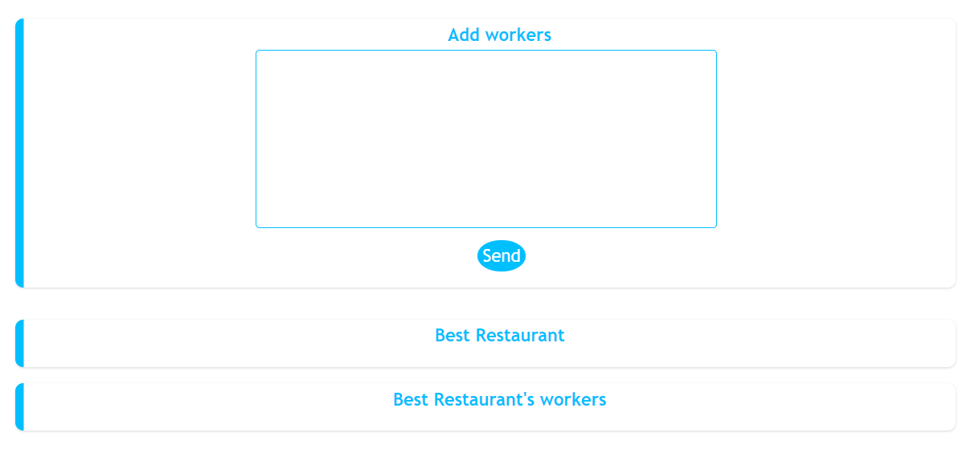

When the **Send** button is clicked you should display the **best** **restaurant** of all the **added** **restaurants** with its **average** **salary** and **best** **salary** from all the **workers** there. To help your friend decide in which restaurant he'll feel best you should display **all** workers in the **best** **restaurant** with their **salaries**.

The best restaurant is the restaurant with the **highest** **average** salary. If two restaurants have the **same** average salary the best restaurant is the **first** one added.

#### Note:

* If there is a restaurant in the input array which is added more than once you should **update (add the new ones)** the workers, average salary and best salary.
* The best restaurant's workers should be **sorted** by their **salaries** by **descending** order.
* Don't forget to **add** an event listener to the **Send** button

### Input

The input will be received from the given **textarea** in the form of an **array** of **strings**. Each string represents a **restaurant** with its **workers**.

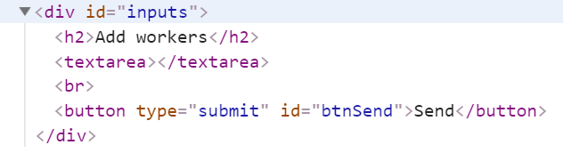

### Output

* Output contains **two strings**
  + The first one is **the best restaurant** in format:

**"Name: {restaurant name} Average Salary: {restaurant avgSalary} Best Salary: {restaurant bestSalary}"**

* + The second one is all the workers in that restaurant in the following format:

**"Name: {worker name} With Salary: {worker salary} Name: {worker2 name} With Salary: {worker2 salary} Name: {worker3 name} With Salary: {worker3 salary}…"**

Output strings must be set like **text content** in the following elements:

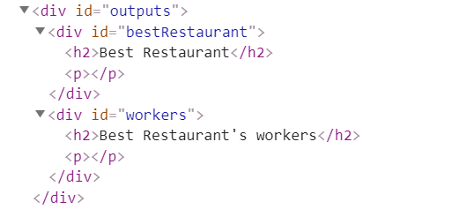

### Constraints

* The workers will be always **unique**

### Examples

|  |  |  |
| --- | --- | --- |
| ****Input**** | ****Output**** | ****Comment**** |
| **["PizzaHut - Peter 500, George 300, Mark 800",**  **"TheLake - Bob 1300, Joe 780, Jane 660"]** | **Name: TheLake Average Salary: 913.33 Best Salary: 1300.00 Name: Bob With Salary: 1300 Name: Joe With Salary: 780 Name: Jane With Salary: 660** | **The added restaurants are: TheLake and PizzaHut.  TheLake has average salary: (1300+780+660)/3= 913.33, and PizzaHub has average salary:  (500+300+800)/2=533.33.  So the best restaurant is TheLake.** |
| **["Mikes - Steve 1000, Ivan 200, Paul 800","Fleet - Maria 850, Janet 650"]** | **Name: Fleet Average Salary: 750.00 Best Salary: 850.00 Name: Maria With Salary: 850 Name: Janet With Salary: 650** |  |

